Number–form Synesthesia

🔢🧠 What is Number–Form Synesthesia?
# Source: Chatgpt (GPT-4-turbo) at [7/24/2025]
Number–form synesthesia is a neurological phenomenon in which numbers (or other sequences like months or years) are automatically visualized as distinct mental maps or spatial arrangements — often in specific shapes, curves, or patterns in the mind's eye.

📘 Definition:
# Source: Chatgpt (GPT-4-turbo) at [7/24/2025]
Number–form synesthesia is a type of synesthesia in which a person sees numbers arranged in specific spatial patterns in their mind, involuntarily and consistently.

Number–form Synesthesia photo
# Source: Windows ScreenShots at [7/26/2025]
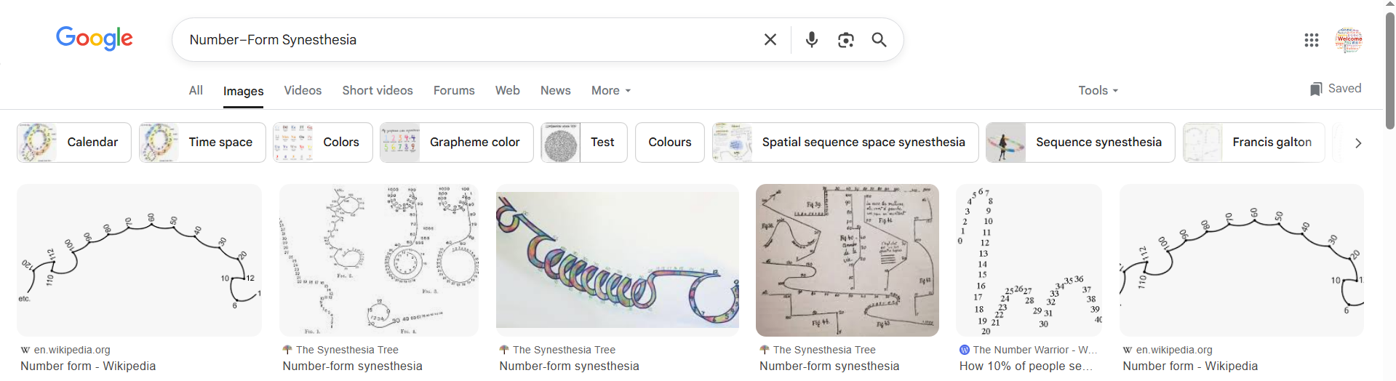
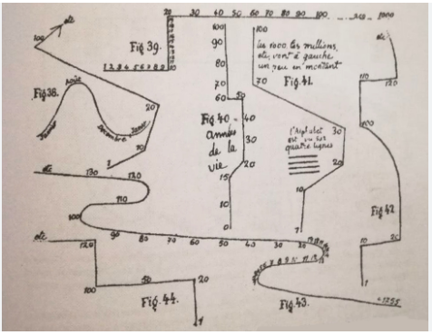
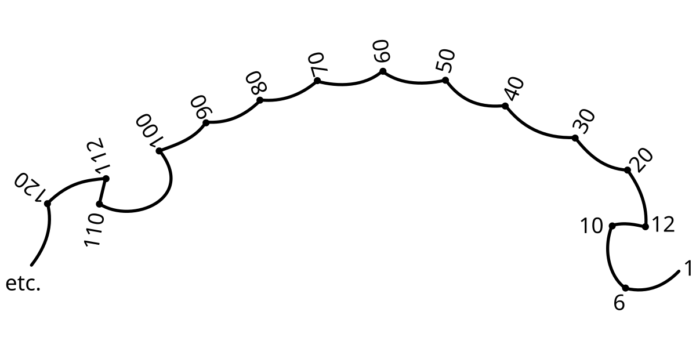

🔍 Key Features:
# Source: Chatgpt (GPT-4-turbo) at [7/24/2025]
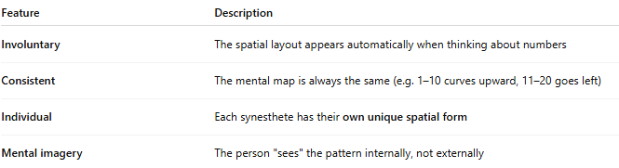
Feature | Description
Involuntary | The spatial layout appears automatically when thinking about numbers
Consistent | The mental map is always the same (e.g. 1–10 curves upward, 11–20 goes left)
Individual | Each synesthete has their own unique spatial form
Mental imagery | The person "sees" the pattern internally, not externally

🧠 What These Maps Might Look Like:
# Source: Chatgpt (GPT-4-turbo) at [7/24/2025]
- Numbers may spiral, zigzag, form ladders, or wrap around a mental space.
- For example:
  - 1–10 = a straight line
  - 11–20 = a turn to the left
  - 100 = at the top right corner of the space
- Some people even see calendars or timelines wrapping around their bodies in 3D space.

🧬 Why Does It Happen?
# Source: Chatgpt (GPT-4-turbo) at [7/24/2025]
- Believed to involve cross-activation between:
  - Brain regions for numerical cognition (e.g., intraparietal sulcus)
  - Regions for spatial processing (e.g., parietal lobes)
- Thought to be genetic or congenital — often lifelong.

🧩 Related Synesthesia Types:
# Source: Chatgpt (GPT-4-turbo) at [7/24/2025]
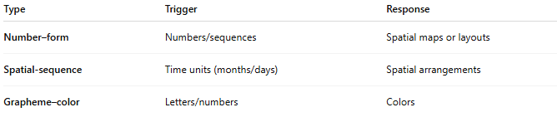
Type | Trigger | Response
Number–form | Numbers/sequences | Spatial maps or layouts
Spatial-sequence | Time units (months/days) | Spatial arrangements
Grapheme–color | Letters/numbers | Colors

✅ Summary:
# Source: Chatgpt (GPT-4-turbo) at [7/24/2025]
Number–form synesthesia is when a person mentally sees numbers in a fixed spatial layout, like a map in their mind.
These mental number lines or shapes appear automatically and stay the same, offering a unique way to process sequences and time.

